* **Bo Motor (Battery Operated)** is an electric motor powered by rechargeable battery.

It offers lower speed, high torque and rpm at low voltage.

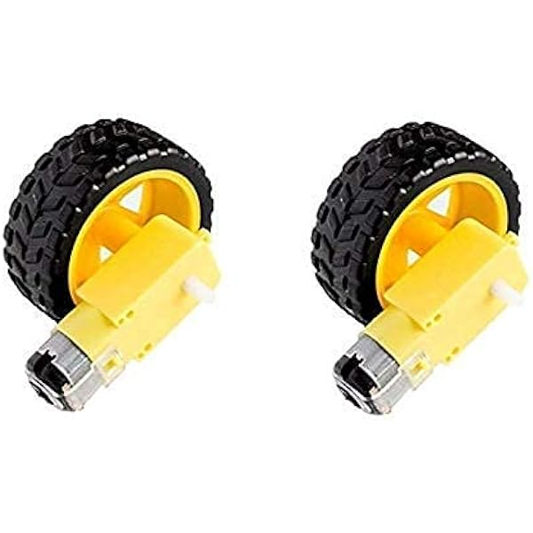

Additional information

|  |  |
| --- | --- |
| **Weight** | **20 g** |
| RPM | 60 RPM, 100 RPM, 300 RPM |
| Operating Voltage (VDC) | **3 ~ 12** |
| Shaft Length (mm) | 8.5 |
| No Load Current (mA) | 40-180mA. |

**-->Application:**

(Plate inside microwave oven,wiper)

Commonly used in portable devices and vechiles.

•Servo motor is used in industrial application of robot.